- what are the latent variables in our PC space ? direction ? value ? is it the same latent variables for DA & GABA neurons ?

- explore projections on different PC combinations
→ DF ON DB ETC
RESULTS @ TONEFB/COMBINATIONS or CROSS-CLASS

if DB-backward trajectory in DF PC space resembles DF-forward trajectory, both populations encode the same direction variable.

→ they look very similar… but so do all 4 traces ?
DF loses separability when projected onto DB

- perform PCA at different time periods (perform on period A and project data from period B on the period A PC space)
→ just clearer trajectories
RESULTS @ TONEFB/

- run analyses only on GF/GB neurons : are they sensitive to US? Also check if GFB neurons are sensitive to direction of movement.

→ in ToneFB : GF/GB not sensitive to reward, has no reaction to reward, it just maintains direction separation and drifts back slowly, it encodes CR movement but just fwd bwd movement, and is direction selective (GB reacts to bwd and GF to fwd and GFB to both)
→ GFB is sensitive to fwd and bwd , discriminates between them ; reward does not do anything like GF/GB.

- run analyses only on DF/DB neurons : do we have distinct opposite trajectories around F/B spontaneous movements? around F/B CRs?

→ CHECK RESULTS @ CLASSES (browser)

in SpontFB distinct and a bit opposite trajectories
In CRFB distinct but not opposite trajectories
In ToneFB a bit distinct, and not opposite (more distinct at reward .. movement)

Dopamine has larger fwd bwd separation for reward than tone : movement is coded ?
if not then could be lick rate/ test by relating lick rate intensity to arc length
(look for each class, cause DFB is driving mean)
→ ToneFB Dopamine separability increases at reward

- can we delineate the 2 components of phasic DA at CS ? (salience vs CR)

- Is the VTA activity dependent or independent of value ? (=do the airpuff-induced backward movements and CS/US-induced backward movements correspond to the same trajectories, or different ones? for GABA only? for DA only?)
- try other dimensionality reduction methods (non linear, eigen space, … ? do we reproduce the results ?)

------------------------------------------------------------------------------------------------------------------------

INTERESTING FINDING :

STRONG ARGUMENT :
MORE SEPARABLE AT REWARD (than at CS for ToneFB) !
AND SEPARABLE AT CR (and at reward for CRFB)

→ MOVEMENT SELECTIVE SEPARABILITY AT REWARD AND AT CR
→ movement coded dynamics

FOR CRFB :
DF : CR and reward trajectory are very similar (along same axis, just amplitude not same)
FOR TONEFB :
DF : CS and reward trajectory are distinct and a bit opposite (not along same axis)
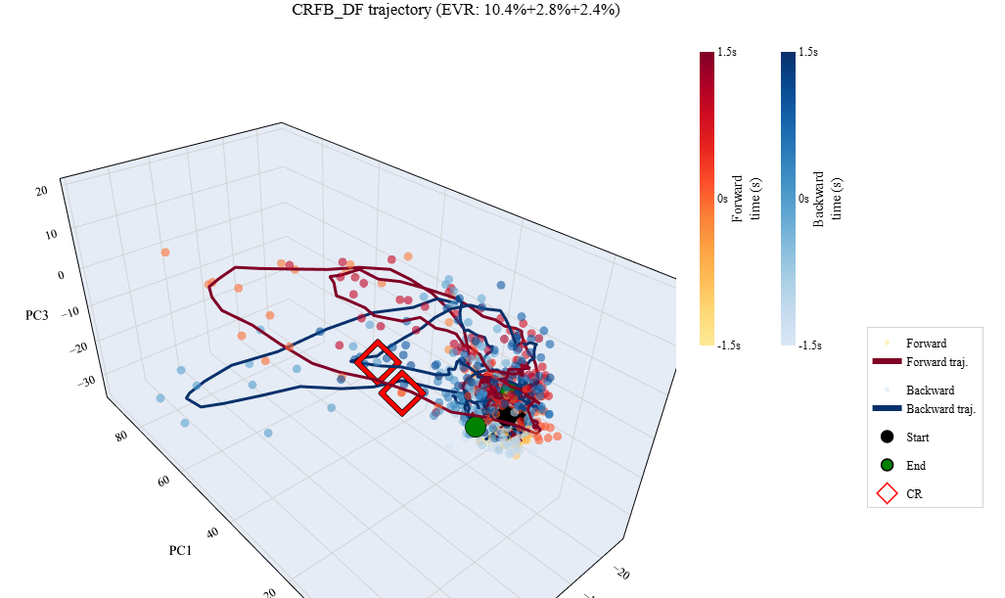
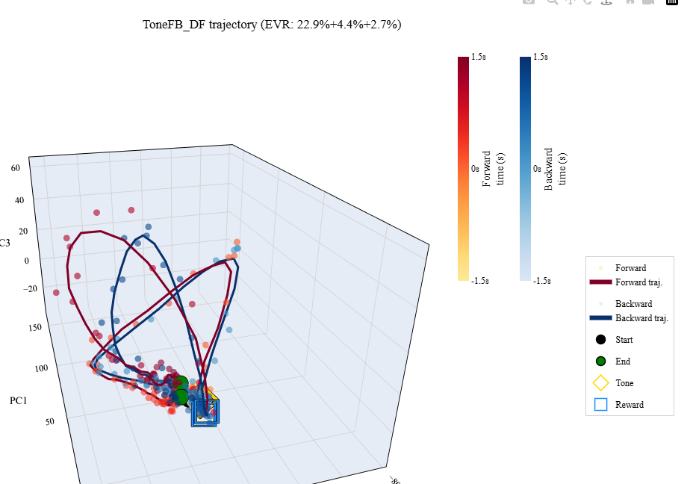

------------------------------------------------------------------------------------------------------------------------

PROJECTION DURING CR TO CS/REWARD :

from CRFB (only data around CR), project data onto PC space of ToneFB (across all data and then along PCs of CS or reward), compute R² to see who captures best the trajectory, does it aligns better with direction/PC of CS or reward trajectory (*prediction : should be with CS because same neurons, just shuffled, but if movement theory true : with reward = mvmt)

- better R² with CS as expected

-for DF :
-- during CS :
-trajectory is really not the same, varies along PC1 & 2 for CS and 1 & 3 for CR (impressive how much it is compressed in PC2, not the same axis of variance !)
- fwd-bwdnot separable in CS, but in CR yes, still separable along PC 3

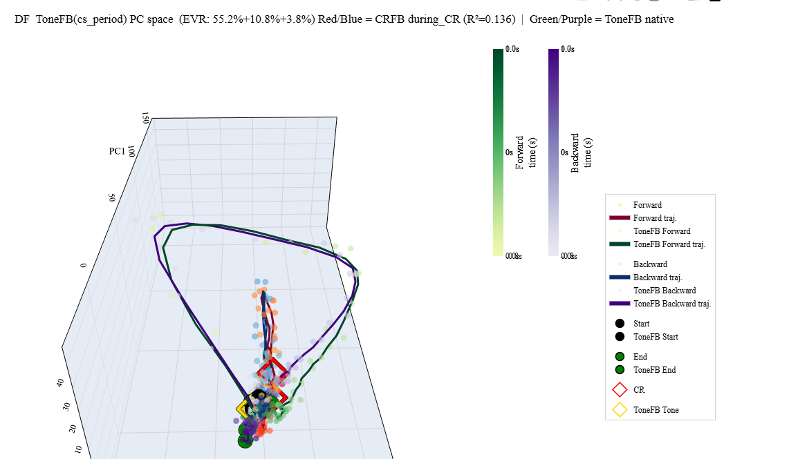

-- during Reward :
- trajectory is quite similar varies along PC1 & 2 for Reward and for CR
- however reward varies along PC3 for separability
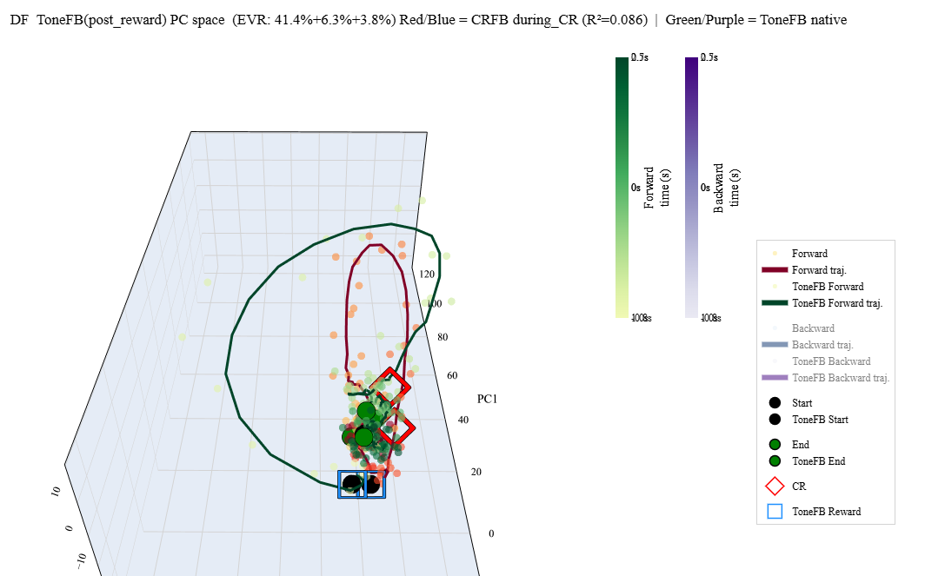

*-→ CR trajectory is more like during reward (*for DF , *measure now using RSA)

-for DFB: trajecrory direction is aligned to CS

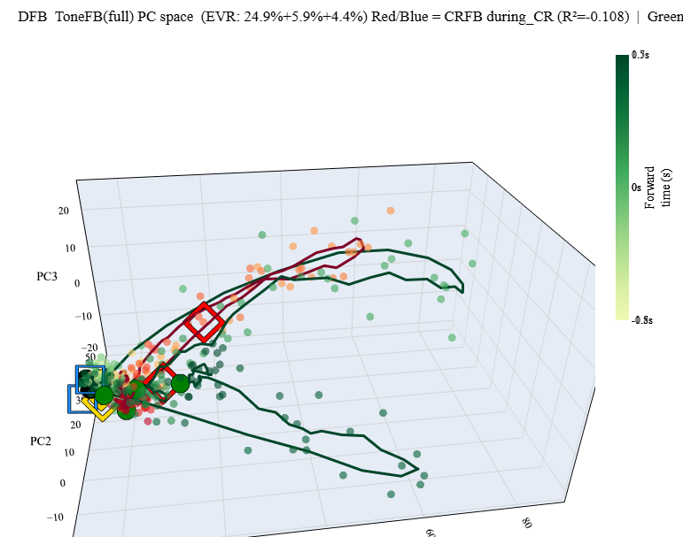

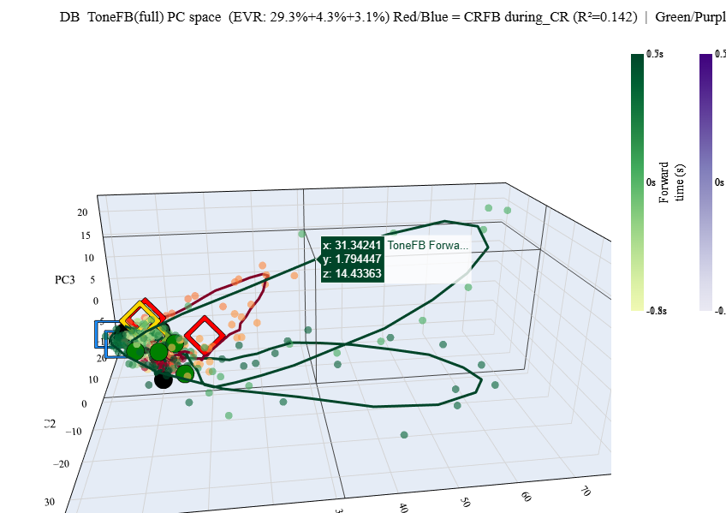
- for DB neither CS or reward, for fwd a bit to CS

opposite, (for causality), fit during CR and project CS/Reward on axis
→ hope dopamine CS on PC of CR is separable by its direction

-for DF :
-- during CS on CR :
-trajectory is really not the same, varies ONLY along PC1 & a bit 3 for CS and 1 , 2 & 3 for CR (impressive how much it is compressed in PC2, not the same axis of variance !)
- fwd-bwdnot separable in CS, but in CR yes, still separable along PC 3
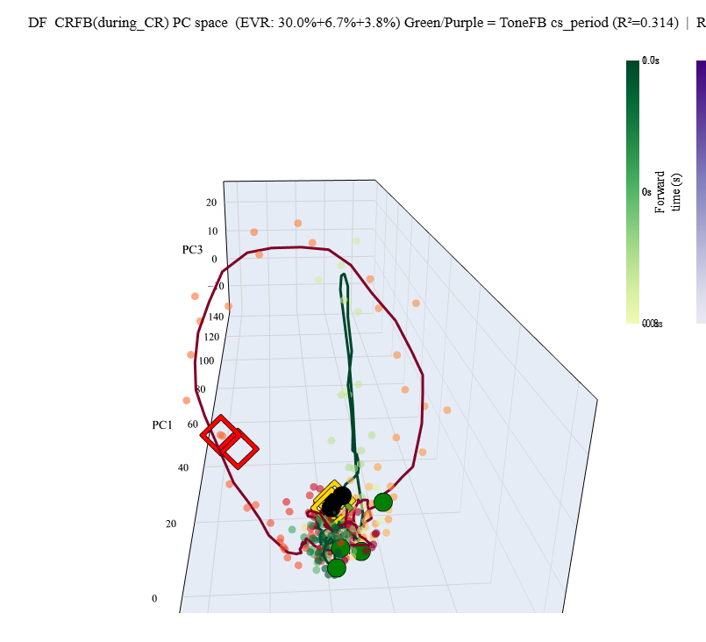

-- during Reward on CR :
- trajectory is quite similar varies along PC1 & 2 for Reward and for CR
- however reward varies along PC3 for separability in CR

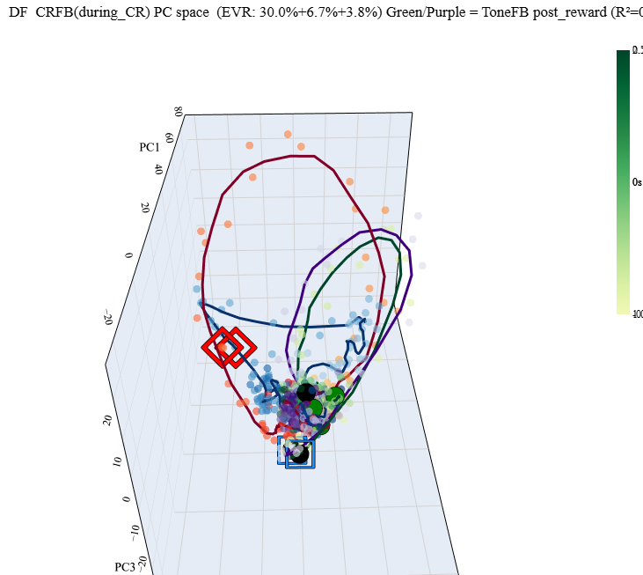

*-→ Reward trajectory is more like during CR (*for DF , *measure now using RSA)

- for DB ; CS period is quite similar to CR
- for DFB : CS period is very similar to CR

------------------------------------------------------------------------------------------------------------------------
project GFB on PC of GF/GB
→ see if GFB has reward deflection
→ RESULT NO DELFECTION, trajectories are extremely similar/parallel

------------------------------------------------------------------------------------------------------------------------

RESULTS :

PC axis of salience/movement ?
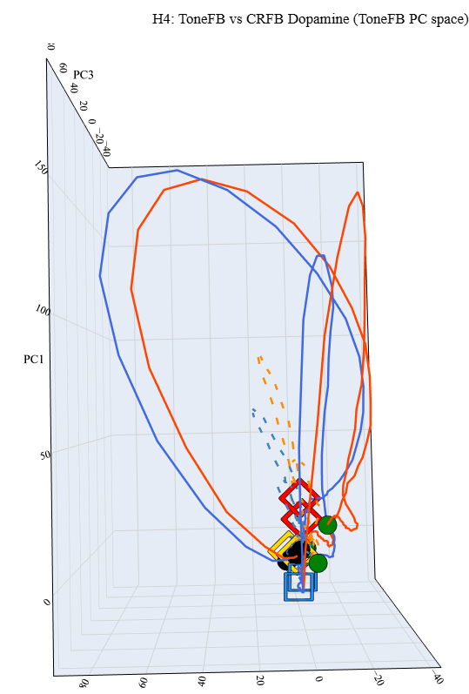
-aligned to tone : reward only along PC1, while tone along both PC 1 & 2 : PC1 can be either reward or movement axis (not enough evidence to delineate)
if PC1 movement axis : PC2 is salience

- aligned to CR projected on tone PC : both ! Diagonal so along PC1 & 2 (a mix of salience and movement)
CR should be along axis of movement, it is more along PC1
→ PC1 might be movement ; CR is mixed with salience so still diagonal, reward curve is averaged out.

